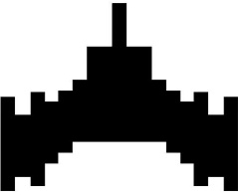**SPACE SURVIVAL**

Space Survival is a space game inspired by the famous “Asteroids” by Atari made in 1979.

**How to Play**

Select the Start Button with mouse to begin playing.

Players control a spaceship in the midst of an asteroid field, navigating through space with incoming asteroids. The objective is to survive as long as possible with no more than 3 Lives.

**Game Controls**

Up Arrow Key – Move Up

Down Arrow Key – Move Down

Left Arrow Key – Move to the Left

Right Arrow Key – Move to the Right

Start Button with Left Click – Start Game

Exit Button with Left Click – End Game



**The Twist**

No Shooting! In this abridged version of Asteroids, the player’s spaceship is equipped with usual thrusters for omnidirectional movement (Up, Down, Left and Right). As well as, the ability to wrap around the x-axis in moving. Without the ability to shoot, Players must rely solely on their piloting skills to survive and avoid collisions.

**Scoring**

In this version of Asteroids, scoring is based solely on survival time. The longer a player lasts, the higher their score. Additionally, bonus points can be earned for near misses and skillful maneuvers.

Are you ready to navigate the treacherous space without the safety net of firepower? Enter this modified Asteroids world and test your mettle against the relentless onslaught of asteroids!